SuperTRUMP

Disaster Recovery Plan

DR Plan Version Date: 06/09/2009
DR Plan Owner: Gregg Reinhart

Mission Critical Level 1
Sarbanes Oxley Level 3
Bank Regulated GECFI Tier 4

Recovery Time Objective¹: 24 hours
Recovery Point Objective²: 24 hours

Approver Title | Approver Name |  | Approval Signature Attachment³ | Date
Business Process Owner | Cindy S Reagan | Approves all business-related aspects of this disaster recovery plan |  | MM/DD/YYYY
IT Application Owner | Gregg Reinhart | Approves all IT-related aspects of this disaster recovery plan |  | MM/DD/YYYY

¹ How long it takes to recover the application from the time the plan is invoked to the time it is handed over to the business
² The point to which the data will be restored before the disaster occurred.
³ Attachment: either this page signed and scanned or an email post-dating the DR Plan date above

1. Disaster Recovery Summary 4
1.1 DR Architecture Overview 4
1.2 Recovery Process 5
1.1.1 Invoke DR Plan 5
1.1.2 Notify Recovery Teams and Impacted Parties 6
1.1.3 Restore Application 7
1.1.4 Test Recovered Application 7
1.1.5 Go/No Go 8
1.1.6 Open up Application to Business Users and Interfaces 8
2. Disaster Recovery Detailed Information 9
2.1 Recovery Process 9
1.1.7 Invoke DR Plan 9
1.1.8 Notify recovery teams and impacted parties 9
1.1.8.1 Notify recovery teams 9
1.1.8.2 Notify impacted parties 9
1.1.9 Restore Application 9
1.1.9.1 Get DR Environment Ready 9
1.1.9.2 Restore Data from Infrastructure Backup 9
1.1.9.3 Restore Databases 10
1.1.9.4 Configure Application Components 10
1.1.10 Test Recovered Application 10
1.1.11 Go/No Go 11
1.1.12 Open up Application to Business Users and Interfaces 11
2.2 Other Key Contacts 11
2.3 Application Architecture 12
1.1.13 Server List 12
1.1.14 Architecture Diagram 12
2.4 System Dependencies and Interfaces 13
2.5 Production Batch / Jobs/ Scripts Schedule 13
2.6 Backup Process when the DR site is operating as production 13
1.1.15 Database backup process when operating in DR 13
1.1.16 Infrastructure backup process when operating in DR 13
2.7 Return to Normal Operations Procedures 14
3. Supporting Information 15
3.1 Recovery Scope 15
3.2 Application – Business Overview 15
1.1.17 Summary 15
1.1.18 Hours of Operation 15
1.1.19 Outage Impact 16
3.3 Assumptions 16
3.4 DR Tests 16
3.5 Revision Control 18
3.6 DR Plan Document Location(s) 18

Disaster Recovery Summary

DR Architecture Overview
SuperTRUMP Webservice
Application Tier | Production Site | DR Site | Application environment recovery | Data recovery
Web servers | Cincinnati | Stamford | QA repurposed | DR Instance on QA environment
Calling Application |  |  | Declare DR to app owners via Email | N/A
Domain Server | N/A | N/A | QA | Rename QA DNS Entry with Prod

SuperTRUMP Desktop
Application Tier | Production Site | DR Site | Application environment recovery | Data recovery
Utility servers | Cincinnati | Alpharetta | QA repurposed | DR Instance on QA environment
User desktop |  |  | Declare DR to all users via Email | N/A
Domain Server | N/A | N/A | QA | Rename QA DNS Entry with Prod

Recovery Process
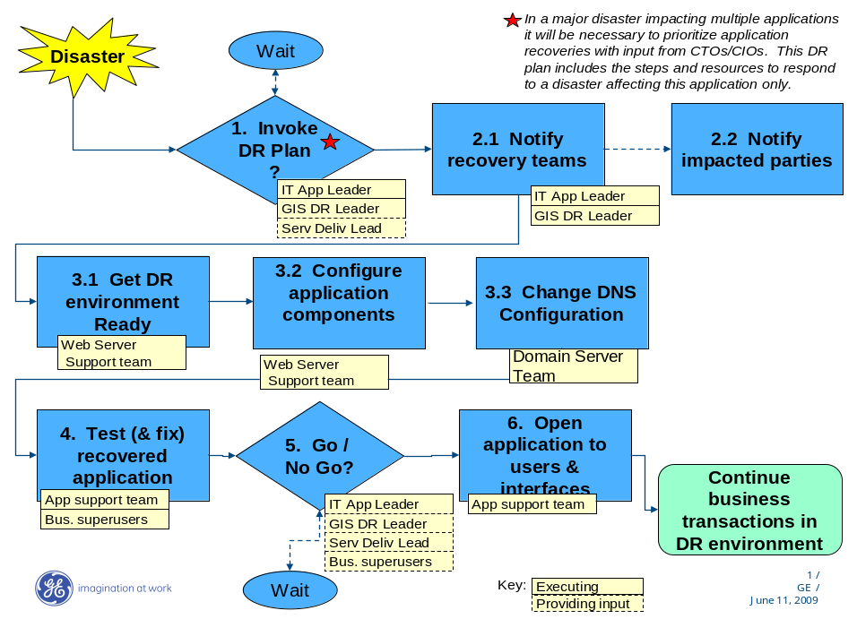

Invoke DR Plan

The following persons are charged with deciding whether or not to invoke the DR plan:
Title | Name | Cell phone | Role at time of disaster | Escalation in case of absence
IT Application Leader | Gregg Reinhart | 203-767-5750 | Overall recovery coordinator | Service Delivery Leader – Paul Bradley
GIS DR Leader | Steve Wolfe |  | GIS recovery coordinator | GIS Compute Leader – Ron Utterbeck
GE Capital Service Delivery Leader | Paul Bradley or  Dave Connell |  | GE Capital overall response coordinator to data center disaster | CTO - Eric Reed

Notify Recovery Teams and Impacted Parties

Notify Recovery Teams. As soon as this plan is invoked, notify all recovery teams in the following table:

Recovery Team | Team Role | Priority | 2 Team Contact Names | Cell phone
GIS Backup Team | Restore data from backup | Immediate | GIS Command Center
Application Support Team | Configure and test application | Immediate | Gregg Reinhart, Nizar Husain, Sanjay Srivastava, Lalit Kumar | 203-767-5750  203-739-5272
Super User Team | Post restore application validation | Within 1 hour | Cindy Reagan / Gladwin DSouza
Web server Team (@CORP GIS L2 CF NT WebServer ) | DR instance Restoration Team | Within 1 hour | Oscar Velasco/Alejandro Acosta
DNS Team | Rename DNS Entry of QA with Prod | Within 1 hour | GIS DNS Team
Note – mention all the teams that need to be alerted to support the recovery operation.

Notify Impacted Parties. At time of disaster the Overall Recovery Coordinator must ensure that someone is assigned to this activity, which will run in parallel with the application recovery. See Section 2.1.2.2 for details

Restore Application

Example where QA environment is repurposed, data is restored from Data Domain: delete this comment and modify the process below as appropriate.
SuperTRUMP Webservice
Process Diagram | Step | Step Instructions | Responsible person / team | Notes
3.1 Get DR Environment Ready | 1 | Rename DNS Entry of QA with Prod | DNS team | See SOP (STwebservice_DR_SOP, Sheet DNS Team)
3.1 Get DR Environment Ready | 2 | Bring Down QA Instance / Activate DR Instance | @CORP GIS L2 CF NT WebServer | See SOP (STwebservice_DR_SOP, Sheet @CORP GIS L2 CF NT WebServer )

SuperTRUMP Desktop
Process Diagram | Step | Step Instructions | Responsible person / team | Notes
3.2 Get DR Environment Ready | 1 | Change DNS Name for ftp | DNS team | See SOP (STDesktop_DR_SOP, Sheet DNS team)
3.2 Get DR Environment Ready | 2 | Refresh ftp | DNS team | See SOP (STDesktop_DR_SOP, Sheet DNS team)

Test Recovered Application

Business test check list | Person responsible | Notes
Recovery point check | Nizar Husain, Sanjay Srivastava, Lalit Kumar
Data integrity check | Cindy Reagan / Gladwin DSouza
Application functionality check | Nizar Husain, Sanjay Srivastava, Lalit Kumar, Cindy Reagan / Gladwin Dsouza

See detailed procedure

Go/No Go

Go / No Go Criteria | Application specific notes
Status and stability of application recovery
Risks of going to DR | Application Configuration, correct version of third party dll (Stserver.dll)
Status / ETR for production environment

Who decides | Title | Notes
Gregg Reinhart | IT Application Leader
Steve Wolfe | GIS DR Leader
Paul Bradley | GE Capital Service Delivery Leader

Open up Application to Business Users and Interfaces

Step | Step Instructions | Responsible person / team | Notes
1 | Notification email to all users | Nizar Husain, Sanjay Srivastava, Lalit Kumar
2

Disaster Recovery Detailed Information

Recovery Process

Invoke DR Plan

No further details

Notify recovery teams and impacted parties

Notify recovery teams
No further details

Notify impacted parties

Impacted Party | Impact | Person will contact them | Phone
Business Owner & Pricing Managers | Application | Nizar Husain | 203-739-5272
IT Owner | Application | Nizar Husain | 203-739-5272
Note: keep this to a short manageable list. For example one person could coordinate the notification of all customers.

Restore Application

Get DR Environment Ready
No further details

Restore Data from Infrastructure Backup

The following attachment contains full details of GIS restore requirements from backup at time of disaster.
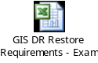

Restore Databases

N/A

Configure Application Components

The following attachment details the steps to configure the application.
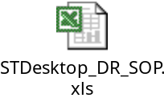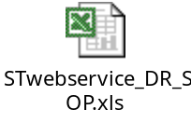

Test Recovered Application
The following attachment is a test plan to be executed at time of disaster. It is adapted from the DR testing test plan.
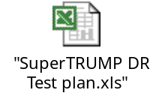

To bring QA up

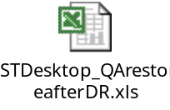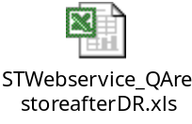

If Production Server comes up



If new server comes for production

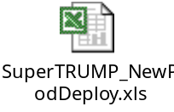

Go/No Go

No further details

Open up Application to Business Users and Interfaces
No further details

Other Key Contacts

Contact Title | Role in DR | Name | Cell phone | Notes
CIO | Escalation point | Martha Poulter
CTO |  | Eric Reed
CML | Initiate and support business continuity plans | Carmine Giannelli
GIS Compute Lead | Escalation in absence of GIS DR Leader | Ron Utterbeck
GIS Backup Lead | Backup support | Tim Allen |  | Contact only if GIS DR Leader unavailable
GIS Compute Run Lead | Escalation point for server/storage/backup support | Eric Jolly

Application Architecture

Server List

Production environment |  |  |  | DR environment
Server Name | Server Role | Location | IP address | Server Name | Server Role | Location | IP address
CEFCIOHPMTCM1/CEFCIOHPMTCM2 | MTS & WEB | Cincinnati | 3.131.89.250/3.131.89.252 | CEFSTCTQMTCM1/CEFSTCTQMTCM2 | MTS & WEB | Stamford | 3.154.11.42/3.154.11.43
Cmfciohpapp01/ Cmfciohpapp02 | FTP Server | Cincinnati | 3.131.91.176/ 3.131.91.178 | Cmfciohqapp01/ Cmfciohqapp02 | FTP Server | Cincinnati | 3.131.91.180/ 3.131.91.182

Exact specific server specification: refer to CADB
<Insert excel file with specifications if available>

Architecture Diagram
The following diagram shows the production and DR application architecture
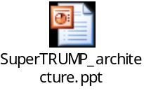
Processing Capacity Estimate

Parameter | Production capacity | Current production operating peak | DR Capacity relative to production
Processing | 100% | ??% | ??%
Memory | 100% | ??% | ??%

These numbers estimated on: mm/dd/yyyy

System Dependencies and Interfaces

The following table lists each interface, and the process to configure the interface to work with the application in the DR environment.

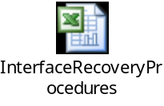

Production Batch / Jobs/ Scripts Schedule

Batch jobs will be impacted as follows:

The batch process will be adapted to run in the DR environment as follows:

Backup Process when the DR site is operating as production

Once the recovery process is complete and business transactions are passing through the application at the DR site, backups are ensured as described below.

Database backup process when operating in DR

N/A

Infrastructure backup process when operating in DR

Backup scope /exclusions will be changed as follows:

Backup frequency will be changed from xxxxxx to xxxxxxx.

The process to ensure that backups are transported / transferred off-site will be changed as follows: refer to GIS data center DR Plan.

Return to Normal Operations Procedures

The following table lists the steps to recover from the DR site back to the production site, assuming that transactions have already been entered into the DR environment and the production site is now available again.

Step | Step Instructions | Responsible person / team | Notes
1
2

Supporting Information

Recovery Scope

In scope | Out of scope
Desktop version (FTP and folder) | Moneycost service (will generate manually during DR)
Webservice (Dll’s and supporting files) | File copy service (manually required files will get copied onto server location from FTP)

Application – Business Overview

Summary
SuperTRUMP is a Pricing tool software package developed by a Third party vendor (Ivory). It comes in two flavors –

- SuperTRUMP Desktop version (STW.exe) - The SuperTRUMP client is a stand-alone application installed in each and every users desktop, used for pricing the deals. Only at the time of launching the application, it gets connect to FTP server for downloading any latest files available on the server.

- Super Trump COM Server version (StServer.dll) - The SuperTRUMP Web Service is a wrapper component built to customize Ivory's Super Trump Server version to CEF application requirements.

- Webservice Prod URL -
http://ceficecluster.comfin.ge.com/BSCEFSuperTRUMPNET/supertrumpservice.asmx
OR
http://ceficecluster.comfin.ge.com/BSCEFSuperTRUMPNET/BSCEFSuperTRUMP.wsdl

Hours of Operation
The SuperTRUMP application is available during the following hours (times are aligned to the XXX time zone):
 | On-line | Batch / Backup | Maintenance / Other
Monday - Friday | 1AM – 6 PM ET
Saturday
Sunday

Outage Impact
The following table describes the impact on the business due to different outage severities.
 | 1 hour outage | 1 day outage | 1 week outage | 1 month outage
Compliance/legal impact
Customer impact
Financial impact
Reputational impact
Impact on other applications

Assumptions
This Recovery Plan is developed and maintained based on the following assumptions:
- The plan is designed to recover from an extended application outage where the expected recovery time will exceed the “maximum acceptable downtime before a disaster is declared.”
- Outage for the business or worst-case interruption where all equipment, electronic files, procedures and documentation, and the host data center are not usable.
- Disaster recovery backups include all systems and files tied to the application being recovered and are kept at a secure off-site location.
- Sufficient and knowledgeable staff is not incapacitated by the interrupting event, and can execute recovery actions
- The backup recovery location is available and not affected by the interruption.
- The business and appropriate technology teams will review and test this plan annually.
- Although this plan is designed for worst case, inherent in the plan strategy is the ability to recover smaller disaster interruption, which is perhaps a more likely situation. Smaller disasters — such as building fires, burst pipes that flood office space, server crashes that result in corrupted data, extended power outages, severe winter storms, and so on — occur with much greater regularity than big disasters.

DR Tests
The objective of DR tests for the SuperTRUMP application is to demonstrate that the DR solution is able to:
- Recover the application at the DR site within the stated recovery time objective (RTO)
- Recover the application to a level of functionality acceptable to the businesses
- Recover the data to a point in time within the recovery point objective

In order to demonstrate that the solution remains capable over time, regardless of changes in infrastructure, software, database, application, etc. the DR solution is tested at least 2 times per year.

The test approach is as follows:

Last DR test results:
<insert link or document>

Revision Control
This document will be updated at least once per year. All change requests should be directed to the Plan Owner.
Revision | Date | Describe Changes | Section & Page # | Author | Business owner sign off on plan and deliverables

DR Plan Document Location(s)

Locations and holders of the controlled approved copies of the DR Plan.
Name of holder | Location of copy | Type
 |  | Electronic copy #1
 |  | Electronic copy #2
 |  | Paper Copy #1
 |  | Paper Copy #2

